**System Requirements**

**NodeJS**

Make sure you have a recent version (8.11 or later) of [Node](https://nodejs.org/en/) installed globally.

We recommend installing Node and Watchman using [Homebrew](http://brew.sh/). Run the following commands in a Terminal after installing Homebrew:

brew install node

brew install watchman

If you have already installed Node on your system, make sure it is Node 8.3 or newer.

[Watchman](https://facebook.github.io/watchman) is a tool by Facebook for watching changes in the filesystem. It is highly recommended you install it for better performance.

**Yarn (recommend)**

‌

Please follow yarn official install guide.‌

​<https://yarnpkg.com/en/docs/install#mac-stable>

### Xcode & CocoaPods

The easiest way to install Xcode is via the [Mac App Store](https://itunes.apple.com/us/app/xcode/id497799835?mt=12). Installing Xcode will also install the iOS Simulator and all the necessary tools to build your iOS app.

If you have already installed Xcode on your system, make sure it is version 9.4 or newer.

#### Command Line Tools

You will also need to install the Xcode Command Line Tools. Open Xcode, then choose "Preferences..." from the Xcode menu. Go to the Locations panel and install the tools by selecting the most recent version in the Command Line Tools dropdown.

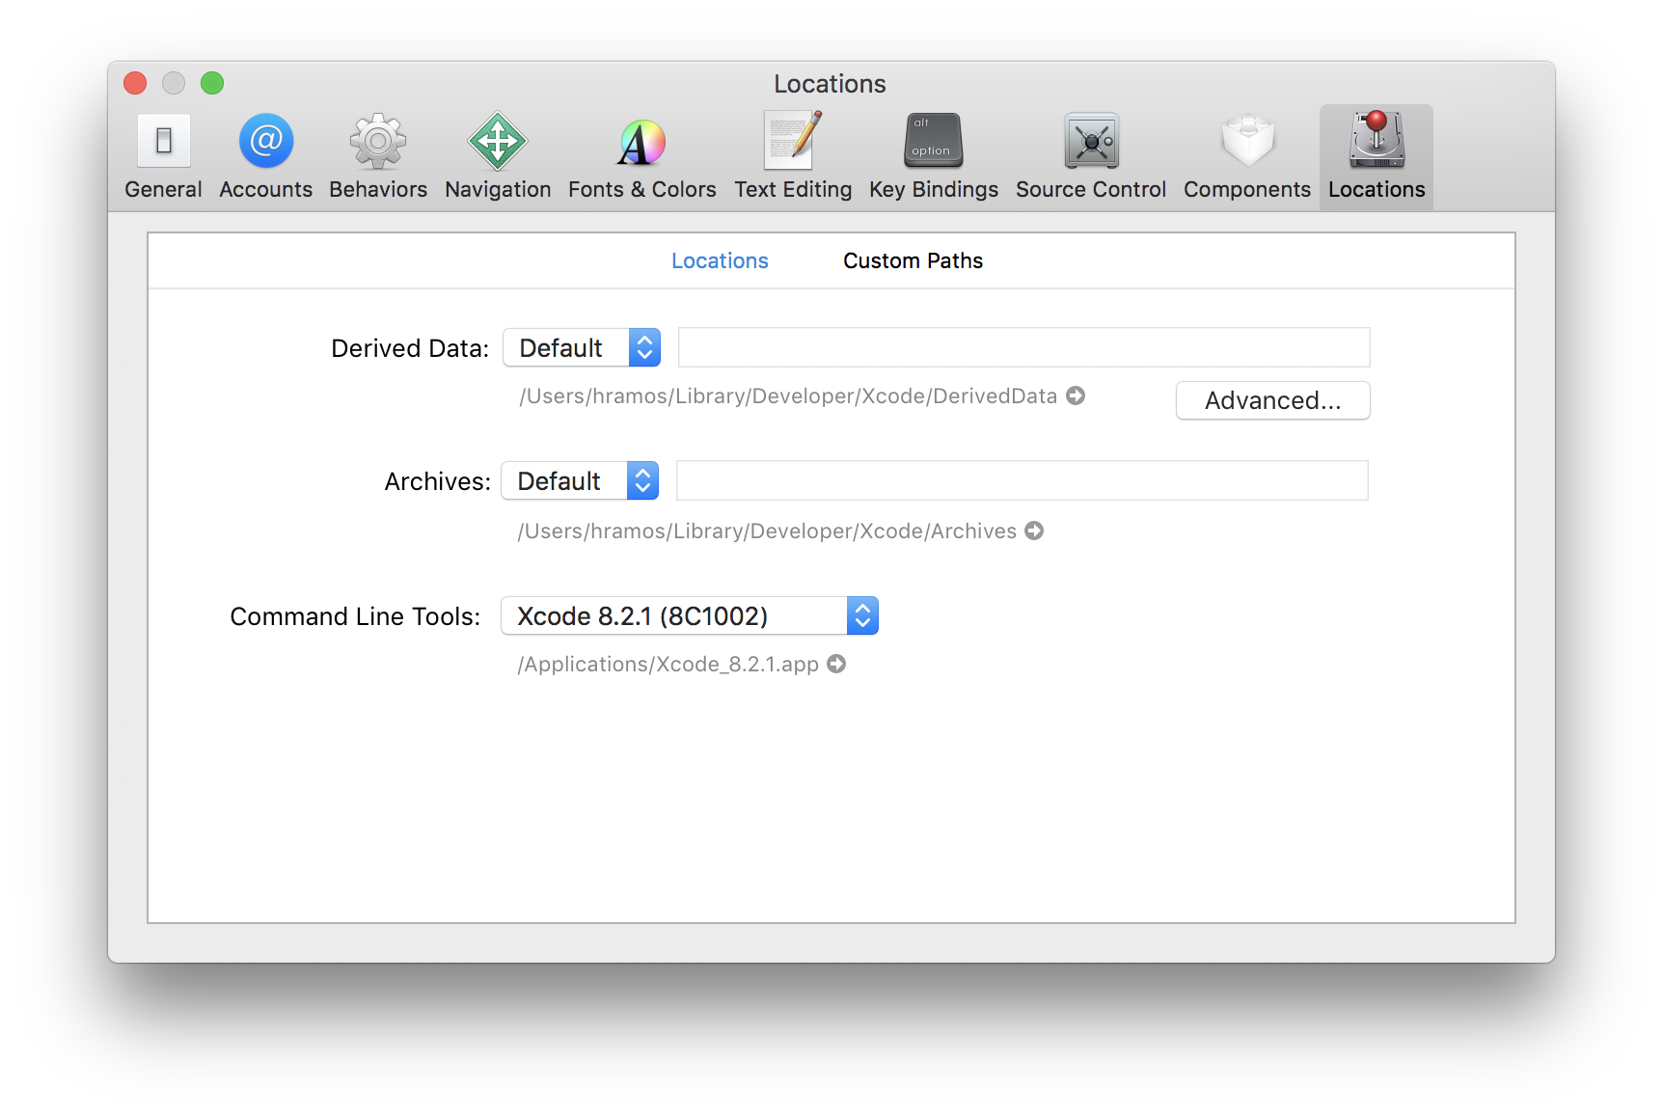

#### Installing an iOS Simulator in Xcode

To install a simulator, open **Xcode > Preferences...** and select the **Components** tab. Select a simulator with the corresponding version of iOS you wish to use.

#### CocoaPods

[CocoaPods](https://cocoapods.org/) is built with Ruby and it will be installable with the default Ruby available on macOS. You can use a Ruby Version manager, however we recommend that you use the standard Ruby available on macOS unless you know what you're doing.

Using the default Ruby install will require you to use sudo when installing gems. (This is only an issue for the duration of the gem installation, though.)

sudo gem install cocoapods

For more information, please visit [CocoaPods Getting Started guide](https://guides.cocoapods.org/using/getting-started.html).

### Java Development Kit

We recommend installing JDK using [Homebrew](https://brew.sh/). Run the following commands in a Terminal after installing Homebrew:

brew cask install adoptopenjdk/openjdk/adoptopenjdk8

If you have already installed JDK on your system, make sure it is JDK 8 or newer.

### Android development environment

Setting up your development environment can be somewhat tedious if you're new to Android development. If you're already familiar with Android development, there are a few things you may need to configure. In either case, please make sure to carefully follow the next few steps.

#### 1. Install Android Studio

[Download and install Android Studio](https://developer.android.com/studio/index.html). Choose a "**Custom**" setup when prompted to select an installation type. Make sure the boxes next to all of the following are checked:

* Android SDK
* Android SDK Platform
* Performance (Intel ® HAXM) ([See here for AMD](https://android-developers.googleblog.com/2018/07/android-emulator-amd-processor-hyper-v.html))
* Android Virtual Device

Then, click "**Next**" to install all of these components.

If the checkboxes are grayed out, you will have a chance to install these components later on.

Once setup has finalized and you're presented with the Welcome screen, proceed to the next step.

#### 2. Install the Android SDK

Android Studio installs the latest Android SDK by default. Building a React Native app with native code, however, requires the Android 9 (Pie) SDK in particular. Additional Android SDKs can be installed through the SDK Manager in Android Studio.

The SDK Manager can be accessed from the "Welcome to Android Studio" screen. Click on "Configure", then select "SDK Manager".

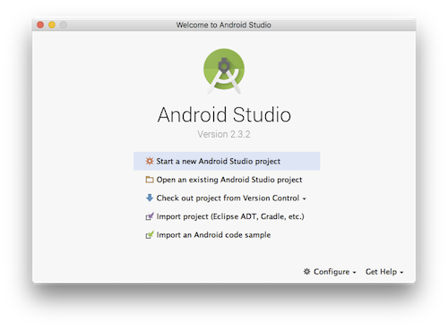

The SDK Manager can also be found within the Android Studio "Preferences" dialog, under **Appearance & Behavior** → **System Settings** → **Android SDK**.

Select the "SDK Platforms" tab from within the SDK Manager, then check the box next to "Show Package Details" in the bottom right corner. Look for and expand the Android 9 (Pie) entry, then make sure the following items are checked:

* Android SDK Platform 28
* Intel x86 Atom_64 System Image or Google APIs Intel x86 Atom System Image

Next, select the "SDK Tools" tab and check the box next to "Show Package Details" here as well. Look for and expand the "Android SDK Build-Tools" entry, then make sure that 29.0.2 is selected.

Finally, click "Apply" to download and install the Android SDK and related build tools.

#### 3. Configure the ANDROID_HOME environment variable

The React Native tools require some environment variables to be set up in order to build apps with native code.

Add the following lines to your $HOME/.bash_profile or $HOME/.bashrc config file:

export ANDROID_HOME=$HOME/Library/Android/sdk

export PATH=$PATH:$ANDROID_HOME/emulator

export PATH=$PATH:$ANDROID_HOME/tools

export PATH=$PATH:$ANDROID_HOME/tools/bin

export PATH=$PATH:$ANDROID_HOME/platform-tools

.bash_profile is specific to bash. If you're using another shell, you will need to edit the appropriate shell-specific config file.

Type source $HOME/.bash_profile to load the config into your current shell. Verify that ANDROID_HOME has been added to your path by running echo $PATH.

## Running on a simulator

Run react-native run-ios or react-native run-android inside your React Native project folder

cd /project_path/Source_Code

react-native run-ios

react-native run-android

## Running on a device

The above command will automatically run your app on the iOS Simulator by default. If you want to run the app on an actual physical iOS device, please follow the instructions here.

<https://facebook.github.io/react-native/docs/running-on-device>